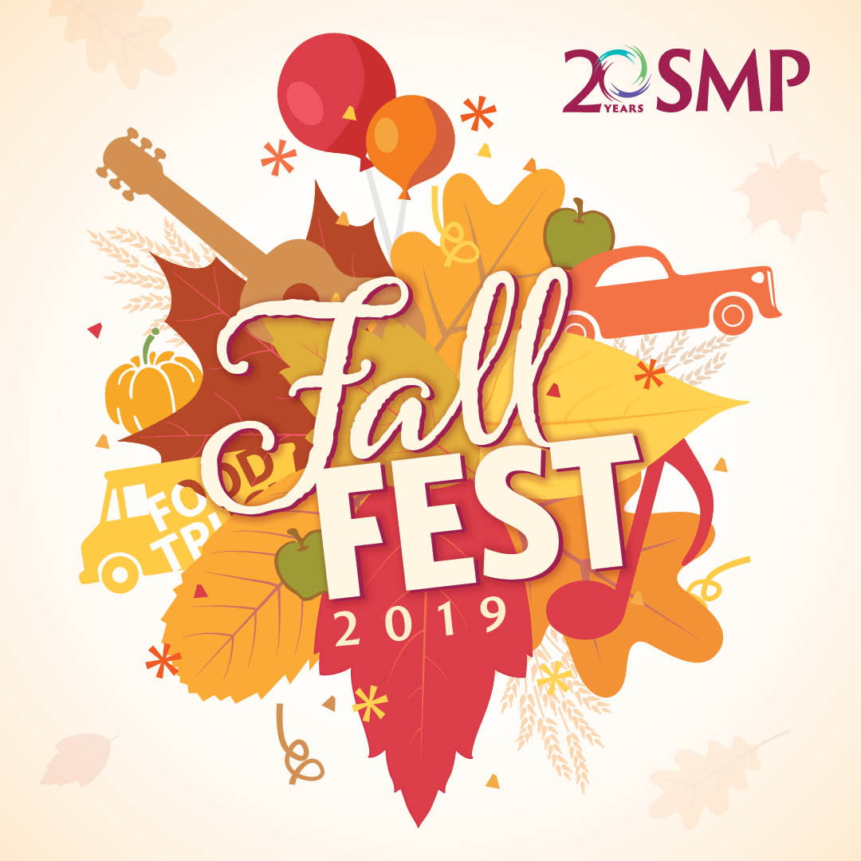

FOOD,

GAMES,

MUSIC,

CRAFTS & More!

**ST. PAUL’S UCC &**

**TEEN CENTRAL**

**PRESENT**



September 27th, 2020

Bring the whole family for this free evening of fall fun! Questions? Contact: [stpaulsmanheim@ptd.net](mailto:stpaulsmanheim@ptd.net)

(717) 665-2447

4:00-6:00PM

St. Paul’s Parking Lot

50 North Main Street

Manheim, PA 17545